CV Prof. Pier Giovanni Baraldi

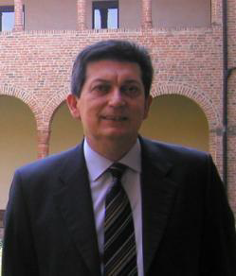
Pier Giovanni Baraldi received his degree in Chemistry in 1974 from the University of Ferrara, where he held a position of Lecturer in the Faculty of Pharmacy (1977–1980) and Associate Professor of Medicinal Chemistry (1980–1987). In 1987, he became full professor of Medicinal Chemistry at the University of Bologna. In 1992, he returned to the University of Ferrara as full professor of Medicinal Chemistry. His expertise in Medicinal Chemistry is recognized by the important scientific production consisting in more than 410 publications including 60 patents (h-index 56). His main research fields are the synthesis of natural products endowed with biological activity, prostaglandins, minor groove alkylating agents with antitumor activity, antiviral agents, ligands for A2A, A2B and A3 adenosine receptors, new antitumor compounds inhibiting tubulin polymerization (combretastatin analogues), cannabinoids agents of the CB2 receptor and TRPV1(vanilloids compounds) and TRPA1 ligands. He is co-founder, of the biopharmaceutical company PharmEste focused on the discovery and development of Transient Receptor Potential (TRPV1) channel therapeutics. He has been promoter of scientific collaborations with several national and international companies (GlaxoSmithKline, Boehringer, Schering-Plough, Dompé farmaceutici, Wyeth, King Pharmaceuticals, Nicox). These cooperation led to the identification of numerous lead compounds some of which are currently under (pre)clinical investigation for the treatment of respiratory disorders (asthma), glaucoma, Parkinson's disease , neuropathic pain and analgesics.
He has been an active member of the Interdisciplinary Centre of Excellence for the Study of Inflammation (ICSI) of Ferrara University, he has been invited to give more than 80 international conferences worldwide.
A recent analysis conducted by The Aspen Institute, in association with Farmindustria, included his team in the top five list of italian excellences in Life Science research. He is a component of the editorial board of a series of international organic/medicinal chemistry journals (Journal of Medicinal Chemistry, Bioorganic and Medicinal Chemistry Letters, Bioorganic and Medicinal Chemistry, ChemMedChem, Current Medicinal Chemistry).

